

Computer Engineering Department
Course name: Web Technologies
Course code: 2CP08
Faculty: Prof Kirtikumar Sharma

ID: 23CP029
Name: Viral Vipulkumar Bhoi
Topic: Report of LAB - 7

LAB 7: JavaScript:2 (Events and HTML Document Object Model)

TABLE OF CONTENT:

7.1 Brief introduction of used JS . . . . . . . . . . . . . . . . . . . . . . . . . . . . . . . . . . . . . . . . . . . . . . . . 3
7.2 Exercise 1 . . . . . . . . . . . . . . . . . . . . . . . . . . . . . . . . . . . . . . . . . . . . . . . . . . . . . . . . . . . . . . . 4
7.3 Exercise 2 . . . . . . . . . . . . . . . . . . . . . . . . . . . . . . . . . . . . . . . . . . . . . . . . . . . . . . . . . . . . . . . 6
7.4 Exercise 3 . . . . . . . . . . . . . . . . . . . . . . . . . . . . . . . . . . . . . . . . . . . . . . . . . . . . . . . . . . . . . . . 7
7.5 Exercise 4 . . . . . . . . . . . . . . . . . . . . . . . . . . . . . . . . . . . . . . . . . . . . . . . . . . . . . . . . . . . . . . . 9
7.6 Exercise 5 . . . . . . . . . . . . . . . . . . . . . . . . . . . . . . . . . . . . . . . . . . . . . . . . . . . . . . . . . . . . . . . 10
7.7 Exercise 6 . . . . . . . . . . . . . . . . . . . . . . . . . . . . . . . . . . . . . . . . . . . . . . . . . . . . . . . . . . . . . . . 11
7.8 Exercise 7 . . . . . . . . . . . . . . . . . . . . . . . . . . . . . . . . . . . . . . . . . . . . . . . . . . . . . . . . . . . . . . . 13
7.9 Exercise 8 . . . . . . . . . . . . . . . . . . . . . . . . . . . . . . . . . . . . . . . . . . . . . . . . . . . . . . . . . . . . . . . 15
7.10 Exercise 9 . . . . . . . . . . . . . . . . . . . . . . . . . . . . . . . . . . . . . . . . . . . . . . . . . . . . . . . . . . . . . . 18
7.11 Exercise 10 . . . . . . . . . . . . . . . . . . . . . . . . . . . . . . . . . . . . . . . . . . . . . . . . . . . . . . . . . . . . . 23

7.1 Brief introduction of used JS::

- navigator Object:
  - Gives information about the browser (name, version, OS, etc.).
  - e.g. console.log(navigator.userAgent);
- history Object:
  - Helps navigate through browsing history.
  - history.back(); // Go to the previous page
  - history.forward(); // Go to the next page
- location Object:
  - Gives URL details and allows page redirection.
  - console.log(location.href); // Shows the current page URL
  - location.href = "https://google.com"; // Redirect to Google
- event Object:
  - Stores details of user actions like clicks, keypresses, etc.
  - document.addEventListener("click", (event) => {
console.log("Clicked at: X =", event.clientX, "Y =", event.clientY);
});
- Document Object Model (DOM):
  - The Document Object Model (DOM) is a tree-like structure that represents a web page. It allows JavaScript to access and modify HTML and CSS dynamically.
  - The browser converts an HTML page into a DOM tree.
  - JavaScript can add, change, or remove elements in the DOM.
  - The DOM has a hierarchical structure
- Accessing Elements in the DOM:
  - getElementById:
    - Selects an element using its id.
    - document.getElementById("myId").innerText = "Hello!";
  - getElementsByName
    - Selects elements with the same name attribute.
    - let inputs = document.getElementsByName("username");
  - getElementsByClassName
    - Selects elements by class
    - let items = document.getElementsByClassName("myClass");
- addEventListener:
  - Adds an event to an element.
  - document.getElementById("btn").addEventListener("click", () => {
alert("Button clicked!");
});

7.2 Exercise 1: Write a JavaScript to create a button. On click on the button a new window should open up

HTML:

<!DOCTYPE html>
<html lang="en">
<head>
<meta charset="UTF-8">
<meta name="viewport" content="width=device-width, initial-scale=1.0">
<title>Document</title>
</head>
<body>
<button onclick="openWindow()">Open new Window</button>
<script>
function openWindow(){
window.open();
}
</script>
</body>
</html>

OUTPUT:

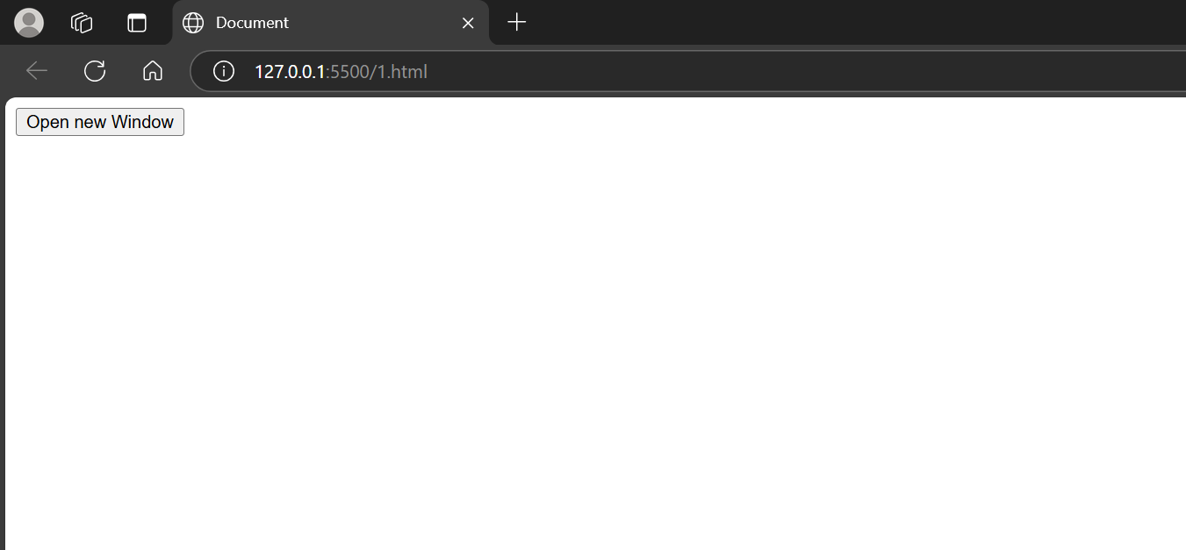
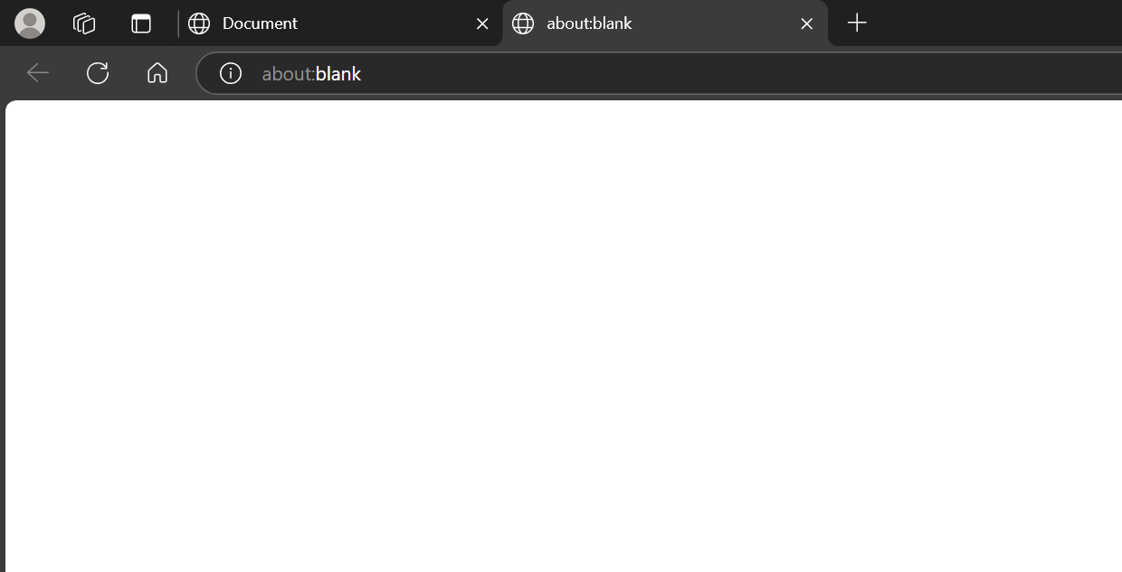

7.3 Exercise 2: Write a JavaScript to get details of location object.

HTML:

<!DOCTYPE html>
<html lang="en">
<head>
<meta charset="UTF-8">
<meta name="viewport" content="width=device-width, initial-scale=1.0">
<title>Document</title>
</head>
<body>
<script>
for(i in location){
document.writeln(i," : ",location[i]);
document.writeln("<br>");
}
</script>
</body>
</html>

OUTPUT:
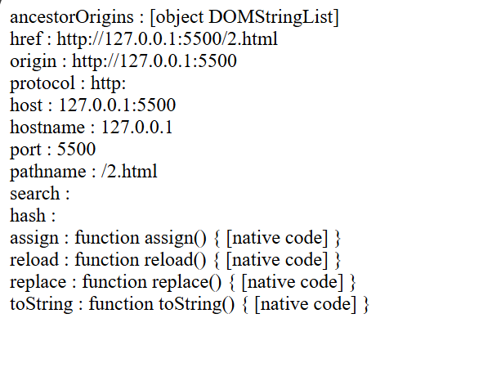

7.4 Exercise 3: Write a JavaScript to get details of navigator object .

HTML:

<!DOCTYPE html>
<html lang="en">
<head>
<meta charset="UTF-8">
<meta name="viewport" content="width=device-width, initial-scale=1.0">
<title>Document</title>
</head>
<body>
<script>
for(i in navigator){
document.writeln(i," : ",navigator[i]);
document.writeln("<br>");
}
</script>
</body>
</html>

OUTPUT:

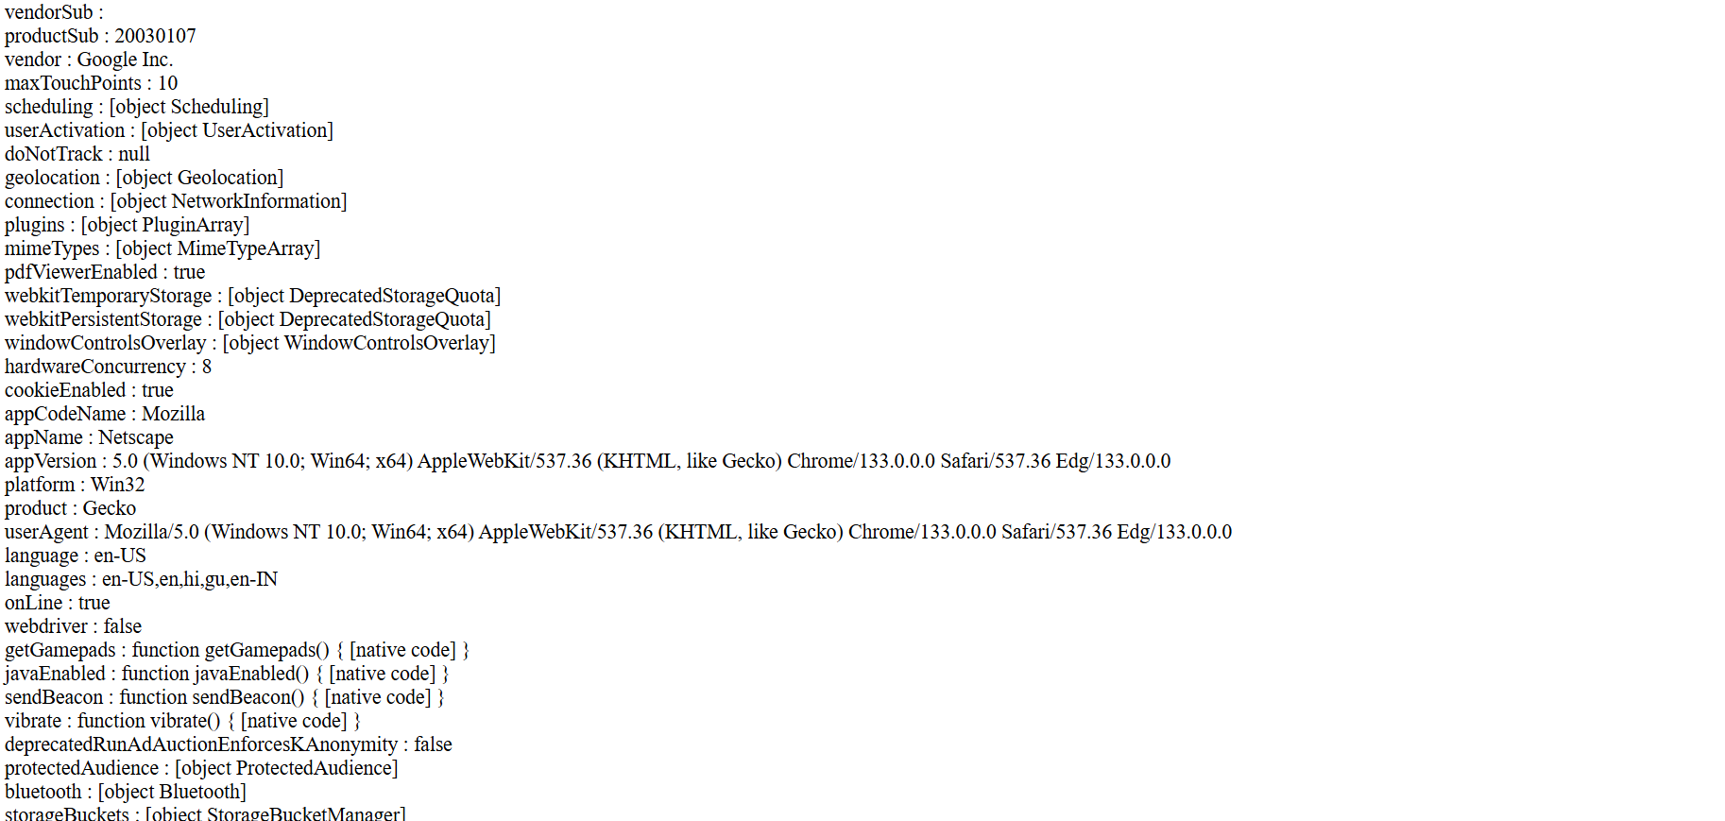

7.5 Exercise 4: Write a JavaScript to retrieve browser name, according browser name open specific version of index page. i.e. chrome_version.html, edge_version.html

HTML:

<!DOCTYPE html>
<html lang="en">
<head>
<meta charset="UTF-8">
<meta name="viewport" content="width=device-width, initial-scale=1.0">
<title>Document</title>
</head>
<body>
<script>
let userAgent = navigator.userAgent.toLowerCase();
if (userAgent.includes("chrome") && !userAgent.includes("edg")) {
// window.location.href = "chrome_version.html";

document.write("CHROME VERSION")
} else if (userAgent.includes("edg")) {
// window.location.href = "edge_version.html";
document.writeln("EDGE VERSION");
} else {
alert("Unsupported browser!");
}
</script>
</body>
</html>

OUTPUT:
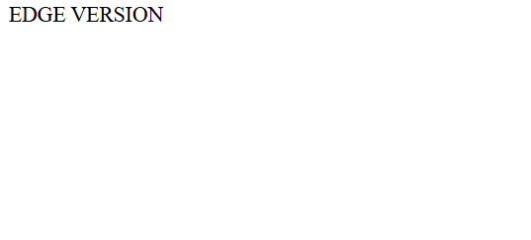
7.6 Exercise 5: Write a JavaScript to get details of History object.

HTML:

<!DOCTYPE html>
<html lang="en">
<head>
<meta charset="UTF-8">
<meta name="viewport" content="width=device-width, initial-scale=1.0">
<title>Document</title>
</head>
<body>
<script>
for(i in history){
document.writeln(i," : ",history[i]);
document.writeln("<br>");
}
</script>
</body>
</html>

OUTPUT:

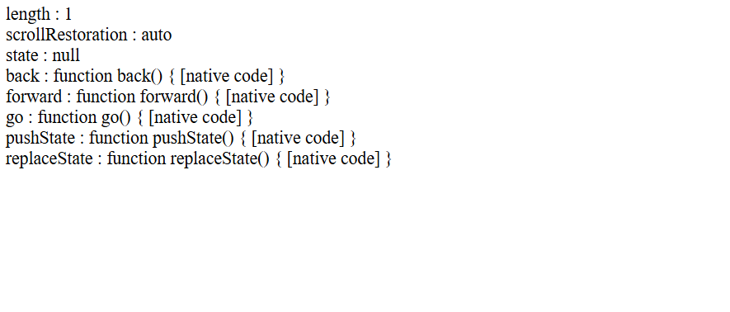

7.7 Exercise 6: Write a JavaScript to Work with change event that occurs when a different item in the selection list is selected. Use innerHTML.

HTML:

<!DOCTYPE html>
<html lang="en">
<head>
<meta charset="UTF-8" />
<meta name="viewport" content="width=device-width, initial-scale=1.0" />
<title>Document</title>
</head>
<body onload="func()" onreset="func()">
<form action="" name="frm">
<select name="item" id="item" onchange="func()">
<option value="Monitor">Monitor</option>
<option value="HDD">HDD</option>
</select>

<select name="prod" id="prod"></select>
</form>
<script>
function func() {
let item = {
Monitor: ["acer 21", "dell 22"],
HDD: ["500GB", "1TB", "2TB"],
};
let option = document.getElementById("item").value;
let s = "";

let tempObj = { 0: "Monitor", 1: "HDD" };

for (i in item[option]) {
s += "<option>" + item[option][i] + "</option>";
}

let change = document.getElementById("prod");
change.innerHTML = s;
}
// func();
</script>
</body>
</html>

OUTPUT:

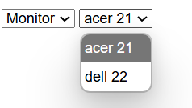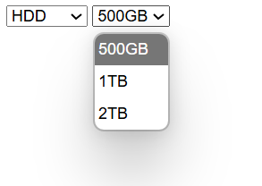

7.8 Exercise 7: Write a JavaScript to retrieve mouse location and display Unicode character and its key code enter from keyboard using event object.

HTML:

<!DOCTYPE html>
<html lang="en">
<head>
<meta charset="UTF-8" />
<meta name="viewport" content="width=device-width, initial-scale=1.0" />
<title>Document</title>
</head>
<body>

<h2>Mouse and Keyboard Event Tracker</h2>
<p id="pos">mouse coordinates.</p>
<p id="key">Pressed key</p>

<script>
addEventListener("mousemove", (event) => {
document.getElementById("pos").innerText =
"Mouse Position - X: " + event.clientX + ", Y: " + event.clientY;
});

addEventListener("keypress", (event) => {
document.getElementById("key").innerText =
"Key Pressed: " + event.key + " (Code: " + event.keyCode + ")";
});

</script>
</body>
</html>

OUTPUT:

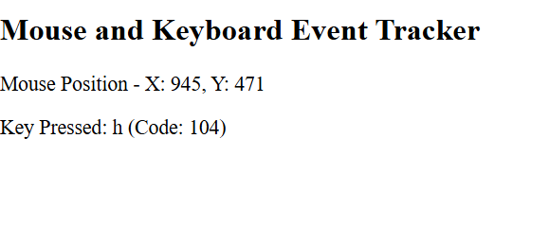

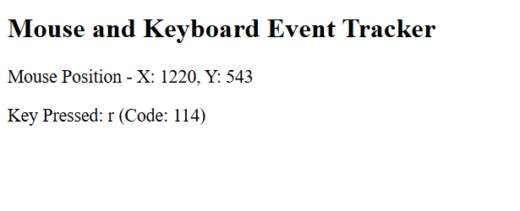

7.9 Exercise 8: Write a JavaScript to validate registeryourself.html page. Give alert message if data is blank. Validate Email, name, password, mobile filed.

HTML:

<!DOCTYPE html>
<html lang="en">
<head>
<meta charset="UTF-8">
<meta name="viewport" content="width=device-width, initial-scale=1.0">
<title>Document</title>
</head>
<body>
<h2>Register Yourself</h2>
<form onsubmit="return validateForm()">
<label for="name">Name:</label>
<input type="text" id="name" name="name"><br><br>
<label for="email">Email:</label>
<input type="email" id="email" name="email"><br><br>
<label for="password">Password:</label>
<input type="password" id="password" name="password"><br><br>
<label for="mobile">Mobile:</label>
<input type="text" id="mobile" name="mobile"><br><br>
<button type="submit">Register</button>
</form>
<script>
function validateForm() {
let name = document.getElementById("name").value.trim();
let email = document.getElementById("email").value.trim();
let password = document.getElementById("password").value.trim();
let mobile = document.getElementById("mobile").value.trim();
let error = "";
for (let i = 0; i < name.length; i++) {
let char = name[i];
if (!((char >= 'A' && char <= 'Z') || (char >= 'a' && char <= 'z') || char === ' ')) {
error += "Name should contain only letters and spaces.\n";
break;
}
}

if (email.indexOf('@') === -1 || email.indexOf('.') === -1 || email.indexOf('@') > email.lastIndexOf('.')) {
error += "Please enter a valid email address.\n";
}
if (password.length < 6) {
error += "Password must be at least 6 characters long.\n";
}
if (mobile.length !== 10) {
error += "Mobile number must be exactly 10 digits.\n";
}
for (let i = 0; i < mobile.length; i++) {
if (mobile[i] < '0' || mobile[i] > '9') {
error += "Mobile number should contain only digits.\n";
break;
}
}
if (error !== "") {
alert(error);
return false;
} else {
errorDiv.innerText = "";
alert("Registration successful!");
return true;
}
}
</script>
</body>
</html>

OUTPUT:

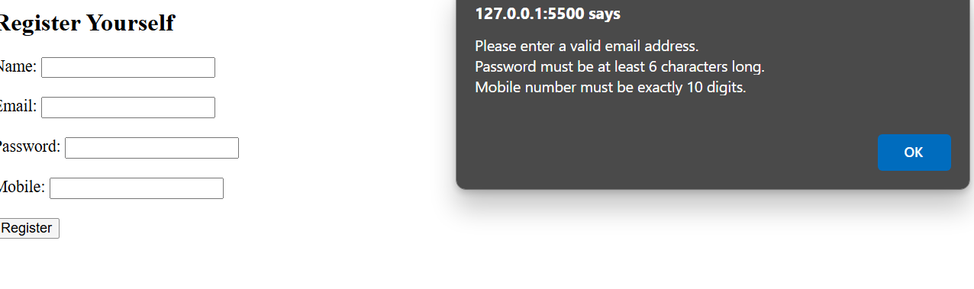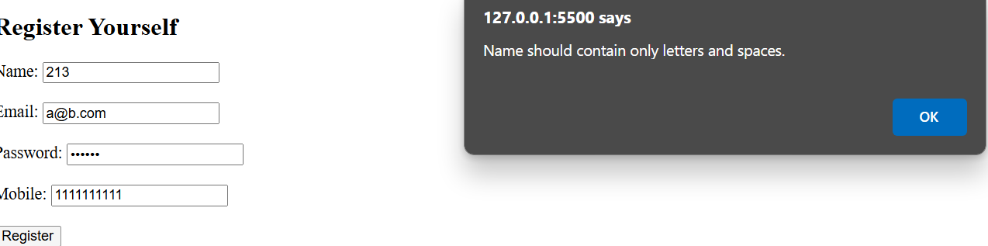

7.10 Exercise 9: Create a stopwatch.

HTML:

<!DOCTYPE html>
<html lang="en">
<head>
<meta charset="UTF-8">
<meta name="viewport" content="width=device-width, initial-scale=1.0">
<title>Document</title>
<style>
#container{
width:100vw;
height:100vh;
display: flex;
flex-direction: column;
align-items: center;
justify-content: center;
}
</style>
</head>
<body>
<div id="container">
<div id="TIME">
00 : 00 : 000
</div>
<div>
<button id="Start">START</button>
<button id="Lap">LAP</button>
<button id="reset">RESET</button>
<div id="lapTiming"></div>
</div>
</div>

<script>
let defTime = "00 : 00 : 000";
let time = document.getElementById("TIME");
let startBtn = document.getElementById("Start");
let lapBtn = document.getElementById("Lap");
let resetBtn = document.getElementById("reset");
let lapTime = document.getElementById("lapTiming")
let milisec = 0;
let on = false;
let timingFunc;

startBtn.addEventListener("click", (event)=> {
if(on){
on = false;
clearInterval(timingFunc);
startBtn.innerText = "START";
// time.innerText = defTime;
}else{
timingFunc = setInterval(()=>{
milisec++;
setTime(milisec);
},1);
on = true;
startBtn.innerText = "STOP";
}
})

lapBtn.addEventListener("click", (event)=> {
lapTime.innerHTML += `<p> ${time.innerText} </p>`;
})

resetBtn.addEventListener("click", (event)=> {
milisec = 0;
on = false;
clearInterval(timingFunc);
startBtn.innerText = "START";
time.innerText = defTime;
lapTime.innerHTML ="";
})

function setTime(milisec){
let min = Math.floor((milisec/60000) % 60);
let sec = Math.floor((milisec/1000) % 60);
let msec = Math.floor(milisec % 1000);
let min_s,sec_s,msec_s;

if(min < 10){
min_s = '0' + min;
}else{
min_s = "" + min;
}

if(sec < 10){
sec_s = '0' + sec;
}else{
sec_s = "" + sec;
}

if(msec < 10){
msec_s = '00' + msec;
}else if(msec>=10 && msec <100){
msec_s = "0" + msec;
}else{
msec_s = "" + msec;
}

time.innerText = `${min_s} : ${sec_s} : ${msec_s}`;
}

</script>
</body>
</html>

OUTPUT:

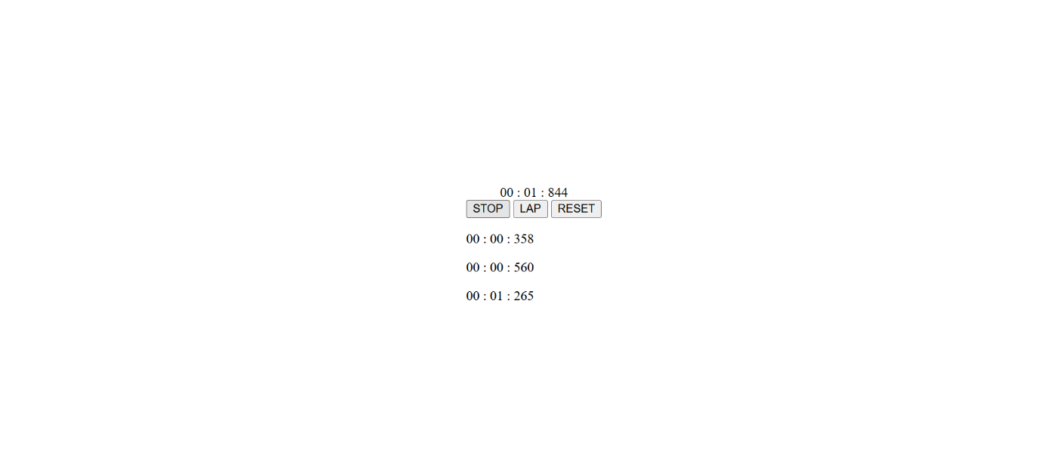

7.11 Exercise 10: if user don’t make any activity for 30 second then logout and redirect to logout page.

HTML:

<!DOCTYPE html>
<html lang="en">
<head>
<meta charset="UTF-8">
<meta name="viewport" content="width=device-width, initial-scale=1.0">
<title>Document</title>
</head>
<body>
<h1>window will Logged out in 30 sec if no activity by user</h1>
<p>activity = mousemove, keypress</p>

<script>
let timingFunc;

function resetTimer() {
clearTimeout(timingFunc);
timingFunc = setTimeout(() => {
alert("Logged out because you are inactive");
window.location.href = "Logout.html";
}, 30000);
}

document.addEventListener("mousemove", resetTimer);
document.addEventListener("keypress", resetTimer);

resetTimer();
</script>

</body>
</html>

OUTPUT:

